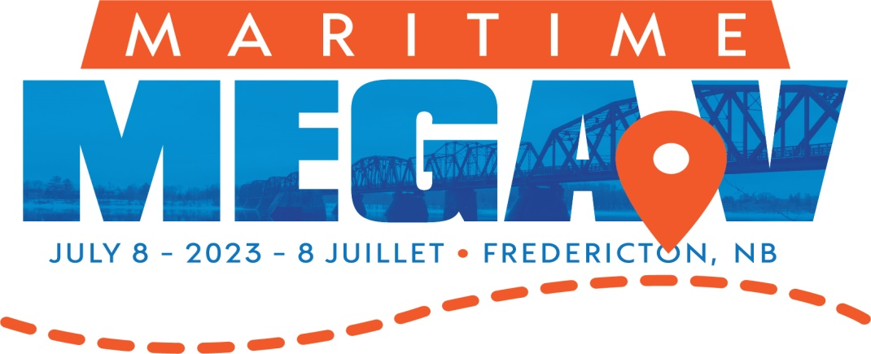

A Message from the Organizing Committee

Geocaching Mega
Fredericton, New Brunswick is proud to host Maritime Mega V (MMV) July 08 2023 with shoulder events occurring July 06 & 07.
Geocaching Mega-Events are a global phenomenon. A Mega-Event connects hundreds (potentially 1000’s -Giga-Event) of adventurers from every level of geocaching. Attending a Mega-Event allows you to experience adventure, family-friendly activities and, of course, all things geocaching.
The benefits of Geocaching are well-documented – it offers a multitude of benefits to your health – decreasing stress (“switch off” from daily grind and appreciate the beauty of nature), mood enhancer (new experiences, meeting new people, learning new things – skills/historical/architecture etc. can cause a spike in dopamine), sharpens your skills (keeping the mind sharp, with activities like puzzles and problem solving can increase your life expectancy, give you a better quality of life and increase your overall health) and increased strength (endorphins, weight loss and increased energy that come from geocaching are just the start. It also allows you to challenge yourself to do what you might not think you are capable of doing!
The history of Fredericton stretches from prehistory to the modern day. This area was first used for seasonal farming by the Mi'kmaq and Maliseet peoples, with maize being the primary crop. In a sense, the site of Fredericton served as a sort of capital (Aucpaque, the "principal village") for First Nations in the area. European settlement of the area began with the construction of Fort Nashwaak by the French in 1692. In 1783, the United Empire Loyalists settled Ste. Anne's Point, and in the next year, renamed the settlement Frederick's Town. The name was later shortened to Fredericton in April 1785.
The city is the capital of the only bilingual province in Canada and is situated along the Wolastoq (Saint John) River, which flows west to east as it bisects the city. The river is the dominant natural feature of the area. As one of the main urban centres in New Brunswick, the city boasts a culturally diverse population of over 59 000, welcoming newcomers from around the world!
An important cultural, artistic, and educational hub for the province, Fredericton is home to two universities, New Brunswick Community College, the New Brunswick College of Craft and Design, and cultural institutions such as the Beaverbrook Art Gallery, the Fredericton Region Museum, and The Playhouse, a performing arts venue.
Our conference theme is Let’s Connect!

Your Sponsorship at Work:
This will be the fifth Maritime Mega, the second one hosted in Fredericton. We want to ensure accessibility to a diverse group of cachers – new and experienced, families of all sizes, young and “seasoned”. We are hoping to keep the costs at a level that finances are not a barrier to participating.
We have a strong educational component to the event, and we hope to invite some experts and “celebrity cachers” to have a “wow” factor with the participants.
Corporate and community sponsors have been integral to the success of past Mega Events and have contributed to a tradition of excellence. Without our sponsors, we would be unable to host such a high-­‐caliber event.
The Market:

Our location gives us the potential to be an international event – with delegates participating from the Maritime Provinces, Quebec and Ontario as well as the Eastern United States. We have received indications from Cachers in Germany, France & Spain. They will potentially be enjoying our city for up to three days with the event, and the potential to stay longer is certainly a possibility. This provides economic spin off to the city and all venders/businesses associated with the event.

In addition, the Atlantic Canada Hidden Histories Geo Tour was launched on July 31, 2022. Geo Tours are a Tourism driver created by geocaching.com.

Maritime Mega Sponsorship Levels

The MMV Steering Committee welcomes all corporate or community sponsors. Sponsorship levels determine the amount of exposure during the conference.

PREMIER SPONSOR: $2,500+

Standard Top-­‐Tier Benefits
- Be acknowledged as a Premier sponsor on MMV website with Sponsor’s logo/image, direct links to Sponsor’s website, and brief sponsor bio
- Be acknowledged as sponsor on front page of conference website with direct links to Sponsor's website or social media as determined by Sponsor
- Be acknowledged on the sponsorship page of the conference program as Premier Sponsor
- Opportunity for an 18 foot booth during the MMV trade show (attended by all MMV attendees and organizers)
- Be recognized as a "Feature Vendor" during the MMV trade show
- Tickets to MMV opening and closing ceremonies, including closing ceremonies (including dinner banquet)

Premier Sponsor Added Benefits

- Be acknowledged in 2 social media posts with direct links to Sponsor’s social media sites on MMV social media pages
- Name on back of attendee’s shirts or ball cap.
- Name inclusion in any MMV media release
- Opportunity to contribute branded items to MMV “swag bags”
- Sponsor logo placement on all key MMV signage
- Full-page advertisement in MMV program (choice based on first-come first-served basis – inside cover, back cover or back outside cover)
- Recognition as Premier Sponsor at MMV (opening ceremonies)

mAJOR SPONSOR: $2,500

Standard Top-Tier Benefits
- Be acknowledged as a Major sponsor on MMV website with Sponsor’s logo/image and direct links to Sponsor’s website
- Be acknowledged on the sponsorship page of the conference program as Major Sponsor
- Opportunity to be the named sponsor for a MMV activity (i.e. Go Go Gymnastics)
- Opportunity for a booth during the MMV trade show (12 foot) (attended by all MMV attendees and organizers)
- Be recognized as a "Feature Vendor" during the MMV trade show -

Major Sponsor Added Benefits
- Be acknowledged in 2 social media posts with direct links to Sponsor’s social media sites
- Opportunity to contribute branded items to MMV “swag bags”
- Sponsor’s sign or banner displayed at key MMV locations
- Complimentary half-page advertisement in MMV program

mAJOR SUPPORTER: $1,000+

Standard Benefits
- Be acknowledged as a Major supporter on MMV websites with Sponsor’s logo/image and direct links to Sponsor’s website.
- Be acknowledged on the sponsorship page of the conference program as Major Supporter
- Opportunity for a booth during the MMV tradeshow (8 ft) (attended by all MMV attendees and organizers)

Major Supporter Added Benefits
- Be acknowledged with other Major Supporters in 2 social media posts
- Complimentary one-third page advertisement in conference program
- Opportunity to contribute branded item for MMV “swag bags”

Official Sponsors: less than $1,000

- Be acknowledged on the sponsorship page of the conference program as an Official sponsor
- Be acknowledged as an Official sponsor in the sponsorship section of the conference website with Sponsor’s logo/image and direct link to Sponsor’s website
- Opportunity for a booth during the trade show (6 ft)(seen by all conference attendees and organizers)
- Complimentary one quarter-page advertisement in conference program

In-Kind Sponsorship

The Maritime Mega Event also welcomes in-­‐kind sponsorship in product, materials, and/or services. If you are interested in contributing an in-­‐kind sponsorship, please contact Carolyn Barnhart 506 260- 0604 or casuba66@gmail.com for more details. The following are examples of In-­‐Kind Sponsorship opportunities available:
- Food Sponsor (Evening Meals)
- Venue Sponsor (Evening Activities)
- Refreshment Sponsor (daily snacks)

OUR COMMITMENT

- Sponsors who support a particular portion of the program (e.g. a guest speaker) will have their donation used solely for such purposes
- All sponsors will receive exposure at the conference in alignment with their level of donation as outlined in the previous section
- The Steering Committee will communicate with the sponsor to ensure that all aspects of the sponsorship levels are carried out to the highest possible standard and in a manner satisfactory to the sponsor’s expectations.

Sponsorship Form

Thank you for your generous support. Your contribution to the 5th Maritime Mega will allow us to continue the legacy of quality geocaching events in the Maritimes!
❒ Yes, we would like to sponsor MMV 2023. Please have a member of the steering committee contact us.
❒ Premier Sponsor $2,500+
❒ Major Sponsor up to $2,500  Major Supporter $1000 +
❒ Official Sponsor less than $1000
❒ In-Kind Sponsorship

❒ Yes, we would like to support MMV and their additional programs. Please have a representative from MMVA contact us to discover the available opportunities for National Sponsorship.

❒ We would like more information before making a decision. Please have a member of the Steering Committee contact us.

Company or Organization: Contact Person: Contact Information:
Please return this form to: MMV
C/O Carolyn Barnhart
Telephone: (506) 260-0604
Email: casuba66@gmail.com

Our Organization, , agrees to support MMV 2023 in the following way(s):

 Monetary donation in the amount of $
(Please make all cheques payable to “MMV 2023”)

Specified Use:

 Product(s) in kind Details:

 Service in kind Details:

The MMV 2023 Steering Committee may contact from our organization, if need be, by using the following information:

Address:

Phone:

Email:
Fax:

